NETDISCOVER TOOL – COMPREHENSIVE TECHNICAL DOCUMENTATION
An ARP-Based Network Discovery Tool for Ethical Hacking & Penetration Testing
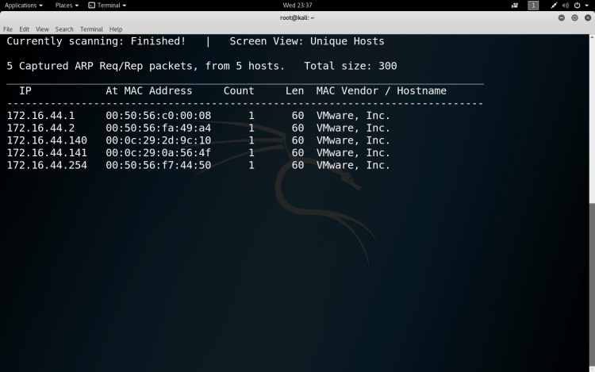
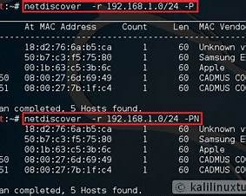
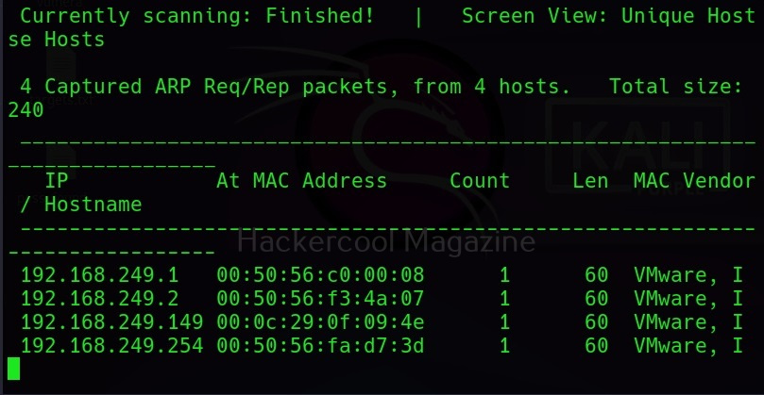
4

ABSTRACT
Internal network discovery is a critical step during penetration testing, especially in local area networks (LANs) and internal assessments. Before scanning ports or exploiting vulnerabilities, it is essential to identify active hosts within the network. This document presents a comprehensive technical study of Netdiscover, an ARP-based network discovery tool widely used in ethical hacking. The report explains the theoretical background of ARP scanning, the internal working mechanism of Netdiscover, command usage, practical case study, advantages, limitations, and defensive considerations. The objective of this documentation is to provide an academic and practical understanding of Netdiscover suitable for cybersecurity coursework, lab records, and professional penetration testing.

1. INTRODUCTION
In penetration testing, attackers and ethical hackers rarely start by directly exploiting a system. Instead, they first identify which devices are present in the network. This process is known as host discovery.
In local networks, traditional techniques like ICMP ping sweeps may fail due to firewall rules or disabled ICMP responses. However, most devices must still respond to ARP (Address Resolution Protocol) requests to communicate on a local network.
Netdiscover leverages this behavior by performing ARP scans to identify live hosts. This makes it extremely effective in discovering devices in switched networks where other discovery methods may fail.

2. OBJECTIVE OF THE STUDY
The objectives of this documentation are:
- To understand ARP-based network discovery
- To study the working mechanism of Netdiscover
- To analyze Netdiscover command usage and options
- To demonstrate real-world usage through a practical case study
- To evaluate strengths, limitations, and security implications
- To provide exam-ready and submission-ready material

3. BACKGROUND: NETWORK DISCOVERY IN CYBER SECURITY
Network discovery is a fundamental part of the Information Gathering phase in penetration testing. It focuses on identifying:
- Live hosts in a network
- IP address ranges in use
- MAC addresses and vendors
- Network gateways and routers
ARP-based discovery is particularly effective in internal networks because ARP traffic cannot be easily blocked without breaking network communication.
Netdiscover uses ARP requests to detect hosts even when they do not respond to higher-level protocols.

4. OVERVIEW OF NETDISCOVER TOOL
Netdiscover is an open-source network discovery tool included by default in Kali Linux. It is designed to scan local networks using ARP requests and identify active devices.
Netdiscover can operate in both passive and active modes:
- Passive mode listens for ARP traffic
- Active mode sends ARP requests to discover hosts
The tool is lightweight, fast, and highly effective for internal reconnaissance.

5. ARCHITECTURE AND WORKING MECHANISM

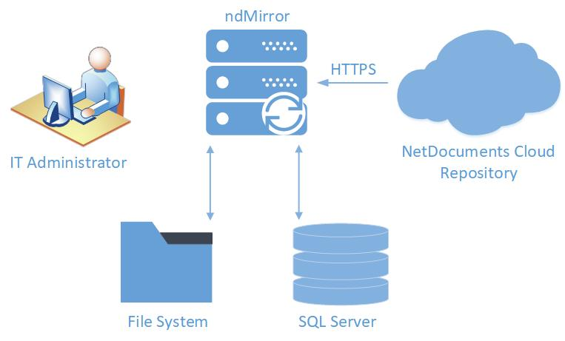
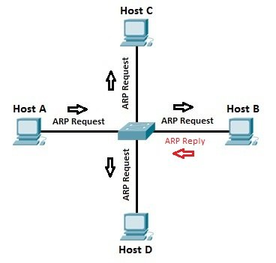
Netdiscover follows a simple yet powerful working mechanism:
- Network Interface Selection
The user specifies or Netdiscover detects the active network interface.
- ARP Request Generation
In active mode, ARP requests are broadcast across the network.
- ARP Response Collection
Devices respond with their IP and MAC addresses.
- Vendor Identification
MAC addresses are mapped to vendor names.
- Result Display
Active hosts are displayed in real time.
This ARP-centric approach ensures accurate host discovery.

6. INSTALLATION AND ENVIRONMENT
Netdiscover is pre-installed in Kali Linux.
To verify installation:
netdiscover --help
Netdiscover requires root privileges because it interacts directly with network interfaces.

7. COMMAND USAGE AND ANALYSIS
7.1 Passive Mode (Stealth Discovery)
netdiscover -p
Listens for ARP traffic without sending packets. Useful for stealthy reconnaissance.

7.2 Active Scan on a Network Range
netdiscover -r 192.168.1.0/24
Actively scans the specified subnet using ARP requests.

7.3 Specify Network Interface
netdiscover -i eth0 -r 192.168.1.0/24
Used when multiple interfaces are present.

7.4 Fast Scan Mode
netdiscover -f -r 192.168.1.0/24
Performs faster scanning at the cost of increased network noise.

7.5 Output to File
netdiscover -r 192.168.1.0/24 > netdiscover_results.txt
Stores discovered hosts for reporting or tool chaining.

8. PRACTICAL CASE STUDY
Scenario
An internal penetration test is conducted on a local network.
Execution
netdiscover -r 192.168.146.0/24
Observations
- Multiple live hosts were identified
- Gateway IP and router MAC address were discovered
- Vendor details revealed virtual machines and servers
Impact Analysis
Netdiscover provided a complete map of active hosts, enabling targeted port scanning and exploitation in later phases.

9. ADVANTAGES OF NETDISCOVER
- Highly effective in internal networks
- Bypasses ICMP blocking
- Fast and accurate host discovery
- Provides MAC and vendor information
- Beginner-friendly and widely used

10. LIMITATIONS OF NETDISCOVER
- Limited to local networks
- Requires root privileges
- Generates noticeable ARP traffic in active mode
- Not suitable for internet-wide scanning

11. NETDISCOVER VS OTHER DISCOVERY TOOLS
Tool | Technique | Best Use Case
Netdiscover | ARP scanning | Internal LAN discovery
Nmap | ICMP/TCP/UDP | Advanced network scanning
ARP-scan | ARP scanning | Fast LAN enumeration
Ping sweep | ICMP | Basic discovery
Netdiscover excels in internal reconnaissance scenarios.

12. SECURITY AND DEFENSIVE CONSIDERATIONS
Organizations can mitigate ARP-based discovery by:
- Implementing network segmentation
- Using intrusion detection systems
- Monitoring ARP traffic anomalies
- Enforcing strong internal access controls

13. LEGAL AND ETHICAL CONSIDERATIONS
Netdiscover must only be used on networks where explicit authorization has been granted. Unauthorized internal scanning may violate organizational policies and cyber laws.

14. CONCLUSION
Netdiscover is a powerful yet simple network discovery tool that demonstrates how easily internal networks can be mapped using ARP-based techniques. Its effectiveness in bypassing ICMP restrictions makes it an essential tool for internal penetration testing. Mastery of Netdiscover provides cybersecurity students and professionals with a strong foundation in internal reconnaissance.

15. REFERENCES
- Kali Linux Official Documentation
- ARP Protocol (RFC 826)
- OWASP Information Gathering Guide

